PAGE 1 — AUTO SCALING GROUP
Topic: Launch Templates

What I did: I opened the EC2 Launch Templates section.
Explanation: This page shows the Launch Templates area where the instance launch configuration is managed.

PAGE 2 — AUTO SCALING GROUP
Topic: Create Launch Template

What I did: I selected Create launch template.
Explanation: This starts the process of creating a reusable EC2 launch configuration.

PAGE 3 — AUTO SCALING GROUP
Topic: Launch Template Name and Description
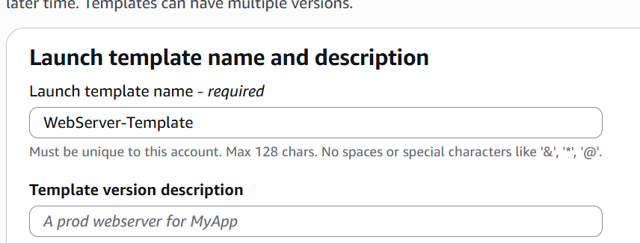
What I did: I entered the launch template name and description.
Explanation: The name and description identify the launch template for later use.

PAGE 4 — AUTO SCALING GROUP
Topic: Application and OS Image
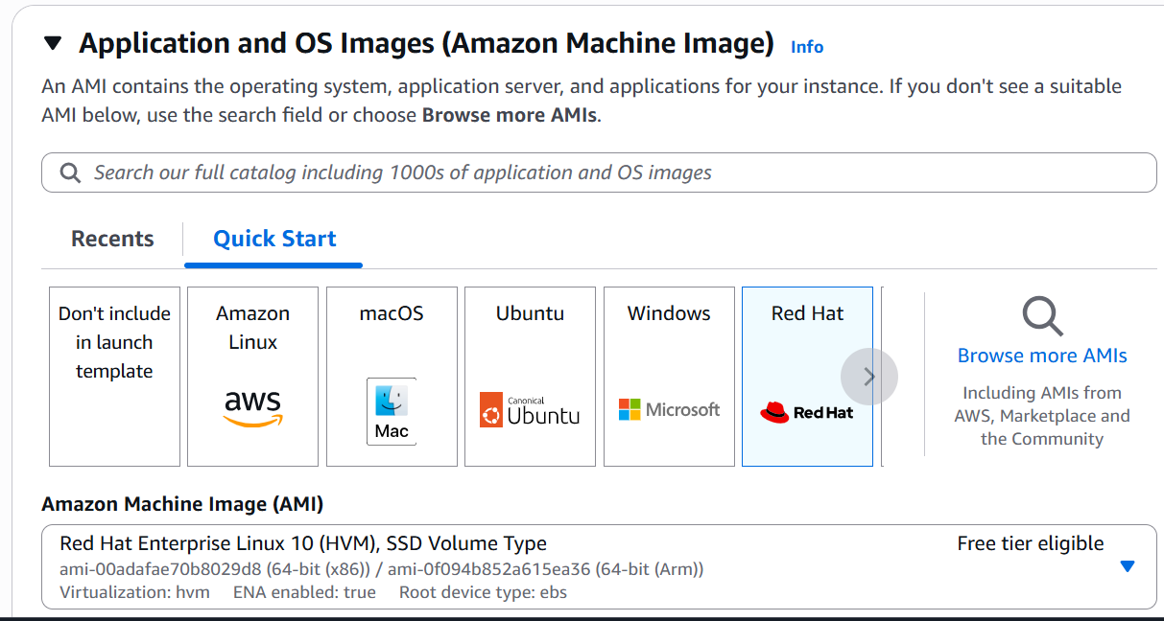
What I did: I selected the required application and operating-system image.
Explanation: The selected AMI provides the operating system for the EC2 instances.

PAGE 5 — AUTO SCALING GROUP
Topic: Instance Type
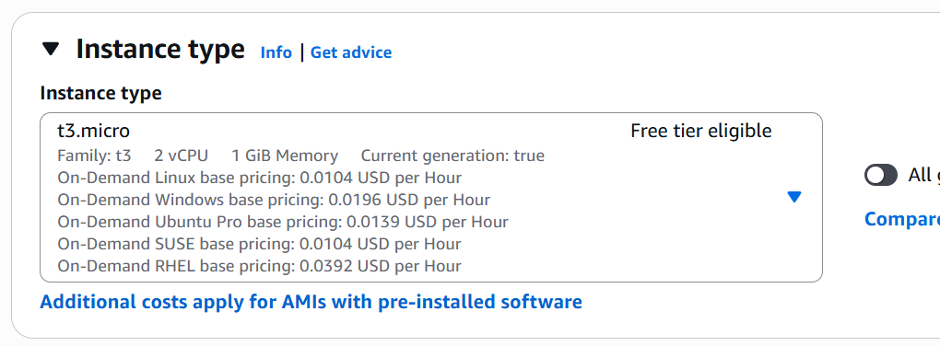
What I did: I selected the required EC2 instance type.
Explanation: The instance type defines the compute resources assigned to the instances.

PAGE 6 — AUTO SCALING GROUP
Topic: Key Pair
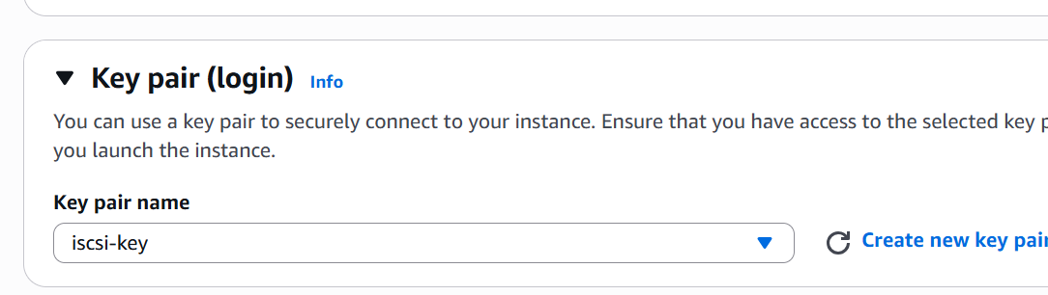
What I did: I selected the required key pair.
Explanation: The key pair is used to securely connect to the EC2 instance.

PAGE 7 — AUTO SCALING GROUP
Topic: Network Settings
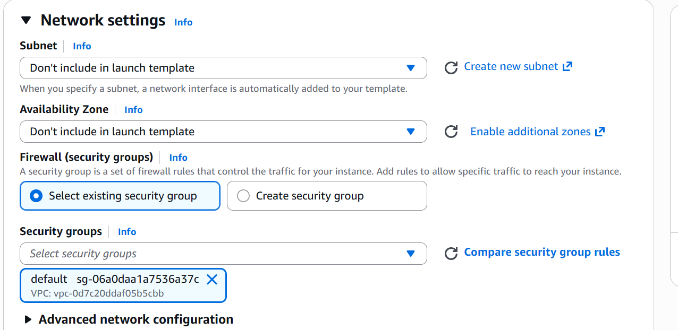
What I did: I configured the VPC, subnet, and security-group settings.
Explanation: These settings define the network in which the EC2 instance will run.

PAGE 8 — AUTO SCALING GROUP
Topic: Advanced Details

What I did: I opened the Advanced details section.
Explanation: This section contains additional launch-template configuration options.

PAGE 9 — AUTO SCALING GROUP
Topic: User Data
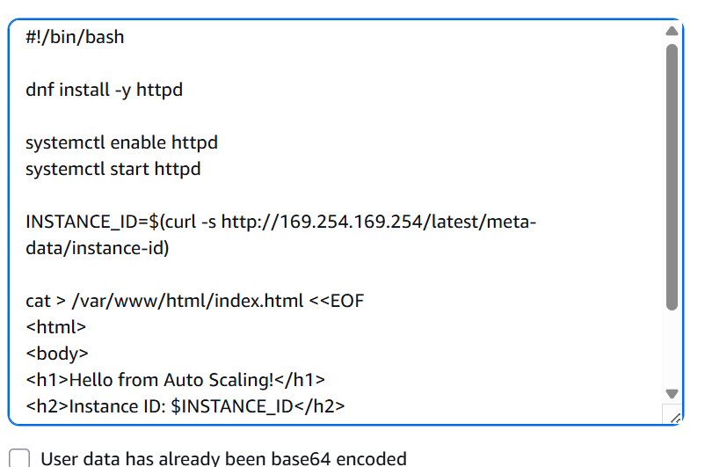
What I did: I entered the required user-data script.
Explanation: The script is provided so commands can run automatically when the instance starts.

PAGE 10 — AUTO SCALING GROUP
Topic: User Data Script
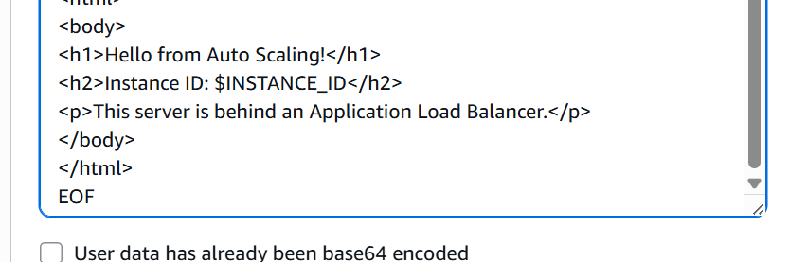
What I did: I reviewed the completed user-data commands.
Explanation: The script installs/configures the required services and prepares the instance for the workload.

PAGE 11 — AUTO SCALING GROUP
Topic: Create Launch Template

What I did: I selected Create launch template to save the configuration.
Explanation: The launch template is created with the settings configured in the previous steps.

PAGE 12 — AUTO SCALING GROUP
Topic: Target Groups

What I did: I opened the Target Groups section.
Explanation: This area is used to create and manage target groups for load balancing.

PAGE 13 — AUTO SCALING GROUP
Topic: Create Target Group
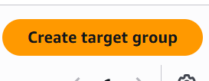
What I did: I selected Create target group.
Explanation: This starts the target-group creation process.

PAGE 14 — AUTO SCALING GROUP
Topic: Target Group Configuration
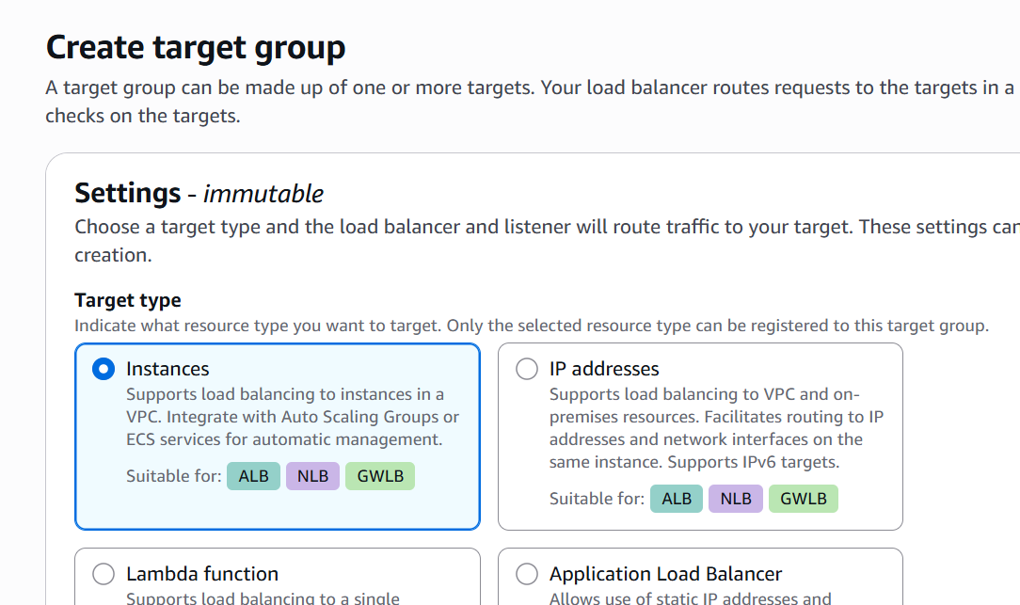
What I did: I selected the target type and configured the target-group options.
Explanation: The target group is prepared to receive traffic from the load balancer.

PAGE 15 — AUTO SCALING GROUP
Topic: Target Group Name and Port
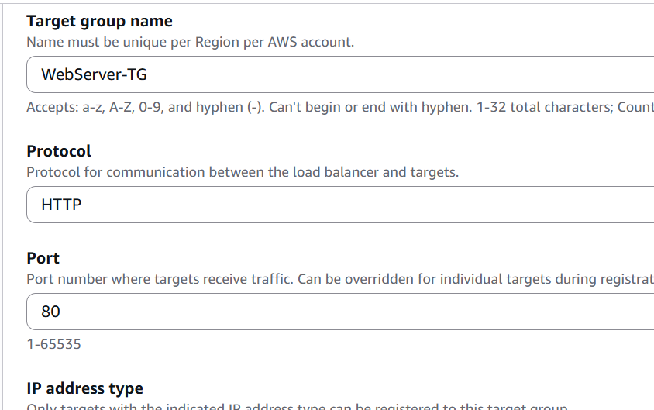
What I did: I entered the target-group name and configured the communication port.
Explanation: These values identify the target group and define the port used for traffic.

PAGE 16 — AUTO SCALING GROUP
Topic: Protocol Version
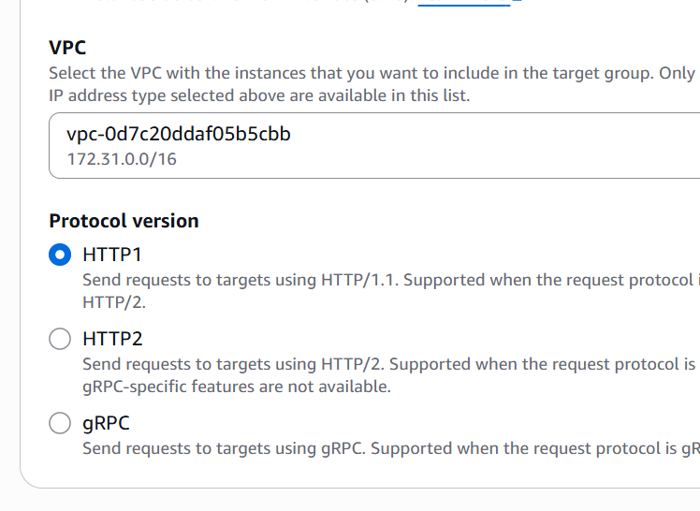
What I did: I selected the required protocol version for the target group.
Explanation: The protocol version defines how traffic is handled between the load balancer and targets.

PAGE 17 — AUTO SCALING GROUP
Topic: Next

What I did: I clicked Next to continue.
Explanation: The wizard moves to the next target-group configuration step.

PAGE 18 — AUTO SCALING GROUP
Topic: Target Group Registration
What I did: I reviewed the target registration page.
Explanation: This page is used to select or register the targets that will receive traffic.

PAGE 19 — AUTO SCALING GROUP
Topic: Load Balancers

What I did: I opened the Load Balancers section.
Explanation: This area is used to create and manage AWS load balancers.

PAGE 20 — AUTO SCALING GROUP
Topic: Create Load Balancer

What I did: I selected Create load balancer.
Explanation: This starts the load-balancer creation workflow.

PAGE 21 — AUTO SCALING GROUP
Topic: Load Balancer Types
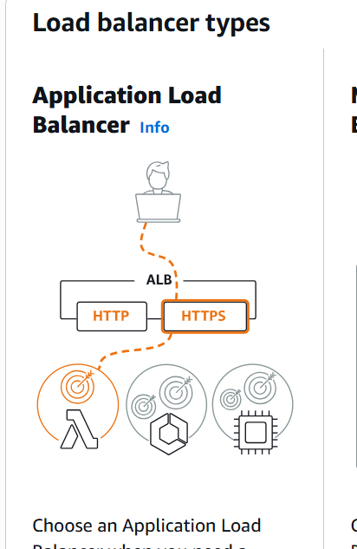
What I did: I reviewed the available load-balancer types and selected Application Load Balancer.
Explanation: The Application Load Balancer is used to distribute application traffic to the registered targets.

PAGE 22 — AUTO SCALING GROUP
Topic: Application Load Balancer
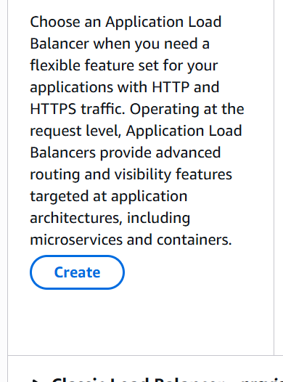
What I did: I selected the Application Load Balancer option.
Explanation: This chooses the load-balancer type for the application traffic.

PAGE 23 — AUTO SCALING GROUP
Topic: Create Application Load Balancer
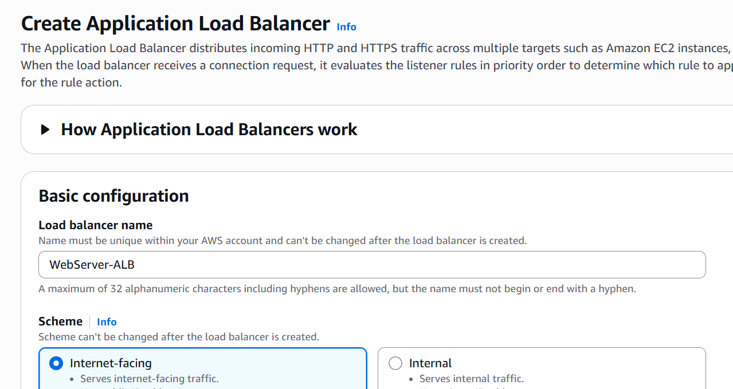
What I did: I opened the Application Load Balancer creation form.
Explanation: The form is used to configure the load balancer and its network settings.

PAGE 24 — AUTO SCALING GROUP
Topic: Network Mapping
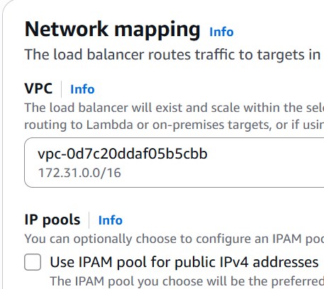
What I did: I configured the VPC and selected the required subnets.
Explanation: The network mapping determines where the load balancer is placed and which Availability Zones it uses.

PAGE 25 — AUTO SCALING GROUP
Topic: Security Groups
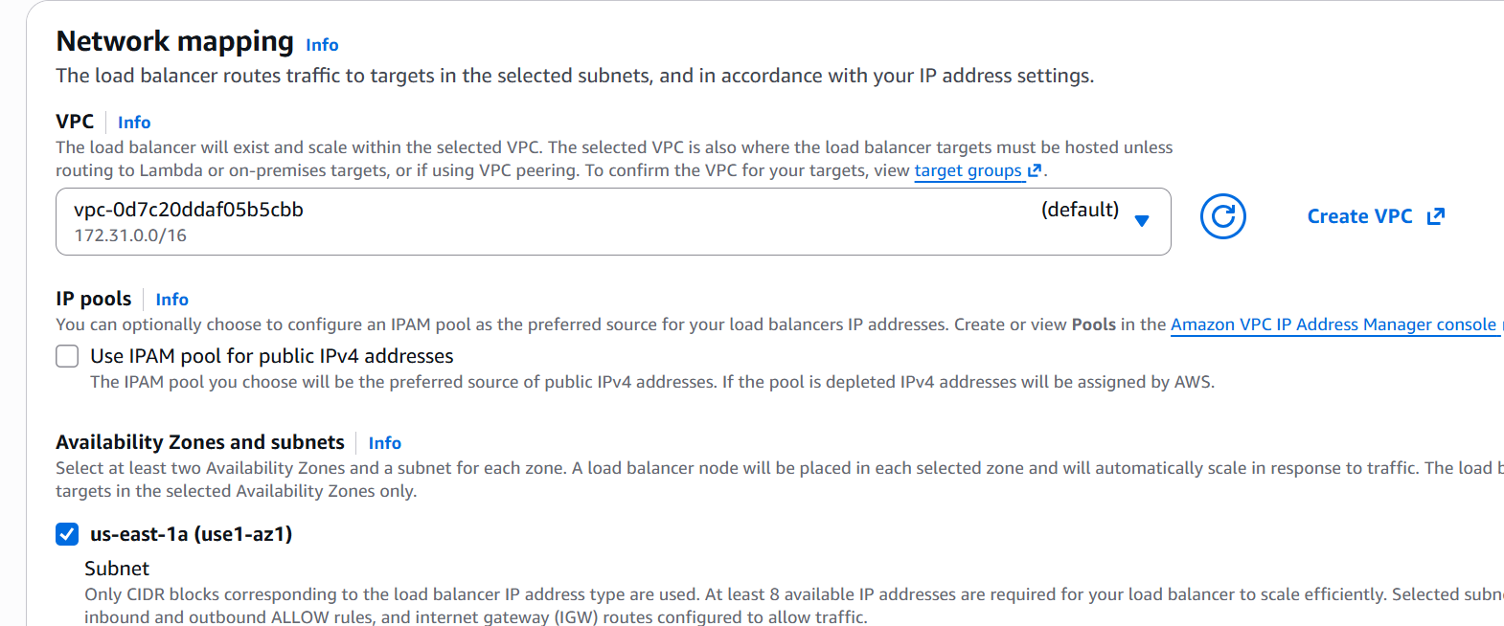
What I did: I selected the required security group for the load balancer.
Explanation: The security group controls network access to the load balancer.

PAGE 26 — AUTO SCALING GROUP
Topic: Listeners and Routing
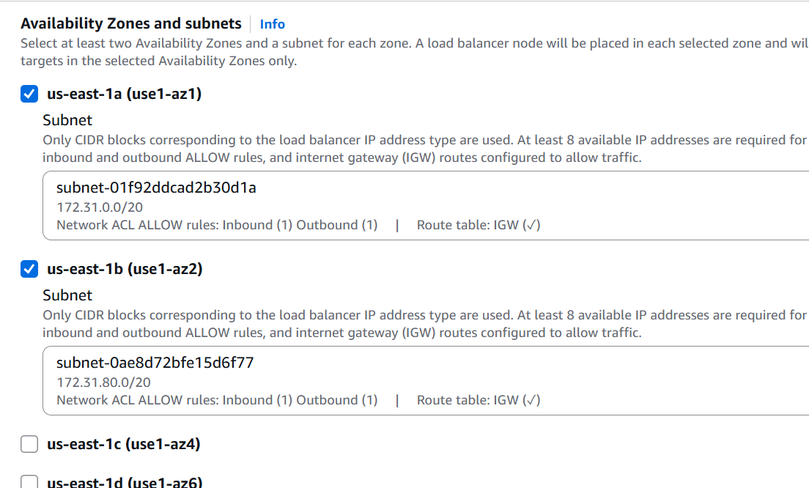
What I did: I reviewed the listener and routing configuration.
Explanation: The listener receives incoming traffic and forwards it to the configured target group.

PAGE 27 — AUTO SCALING GROUP
Topic: Security Groups
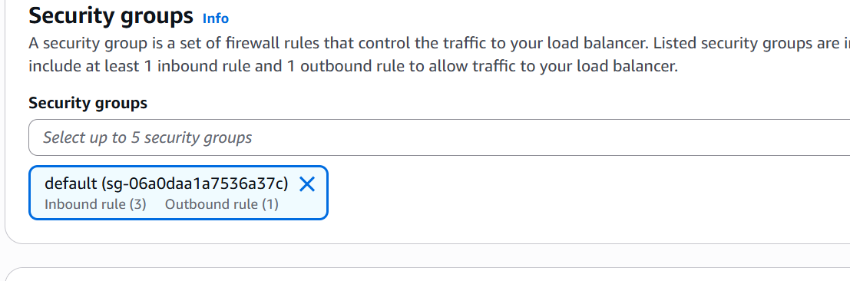
What I did: I confirmed the selected security group.
Explanation: The selected security group will be associated with the load balancer.

PAGE 28 — AUTO SCALING GROUP
Topic: Target Group
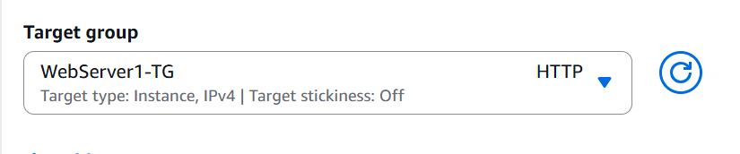
What I did: I selected the target group for the listener.
Explanation: The target group is the destination to which the load balancer forwards traffic.

PAGE 29 — AUTO SCALING GROUP
Topic: Create Load Balancer

What I did: I selected Create load balancer.
Explanation: The configured load balancer is submitted for creation.

PAGE 30 — AUTO SCALING GROUP
Topic: Auto Scaling Groups

What I did: I opened the Auto Scaling Groups section.
Explanation: This area is used to create and manage Auto Scaling groups.

PAGE 31 — AUTO SCALING GROUP
Topic: Create Auto Scaling Group

What I did: I selected Create Auto Scaling group.
Explanation: This starts the Auto Scaling group creation wizard.

PAGE 32 — AUTO SCALING GROUP
Topic: Launch Template
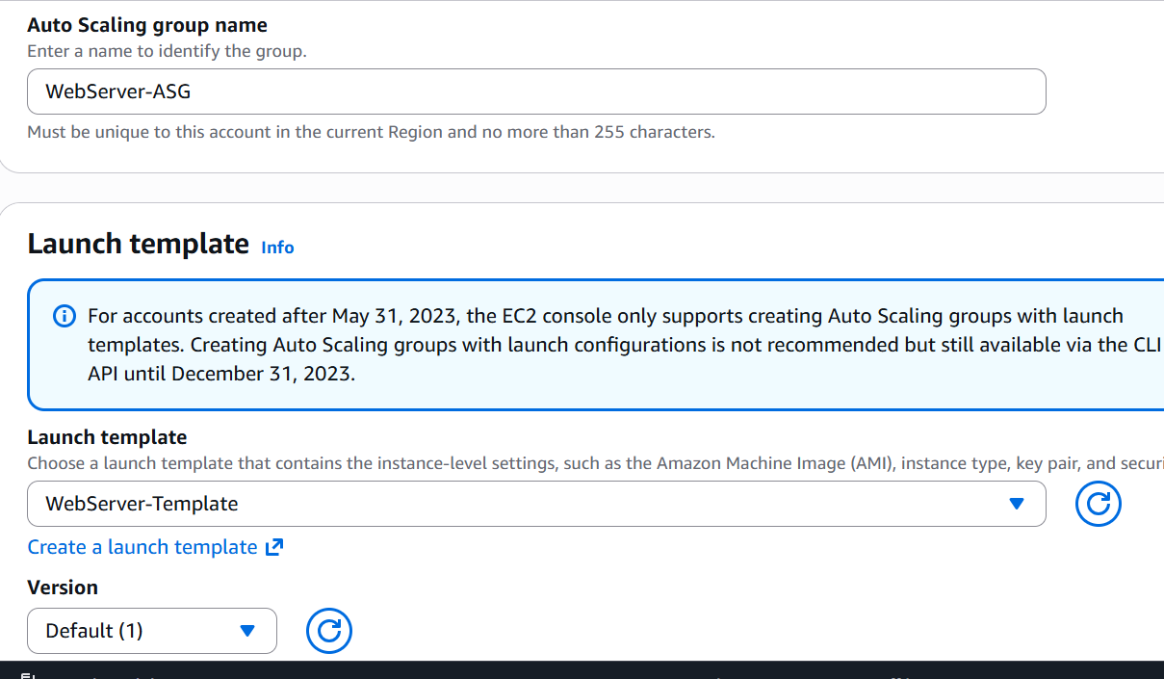
What I did: I selected the launch template for the Auto Scaling group.
Explanation: The launch template provides the EC2 configuration used when new instances are launched.

PAGE 33 — AUTO SCALING GROUP
Topic: Next
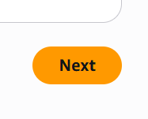
What I did: I clicked Next to continue.
Explanation: The wizard moves from the launch-template step to the network configuration.

PAGE 34 — AUTO SCALING GROUP
Topic: Network Settings
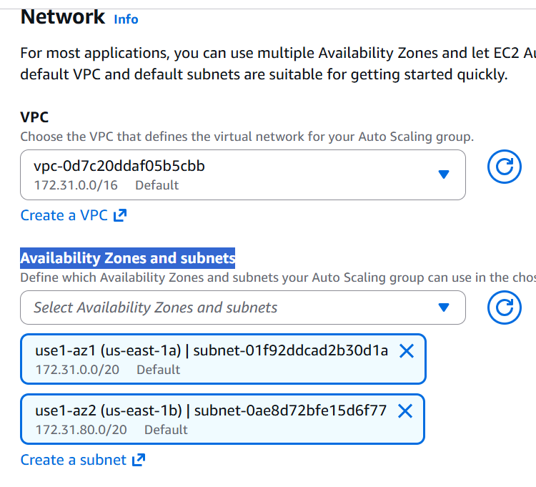
What I did: I configured the VPC and Availability Zone/subnet settings.
Explanation: These settings determine the network placement of the Auto Scaling instances.

PAGE 35 — AUTO SCALING GROUP
Topic: Next

What I did: I clicked Next to continue.
Explanation: The wizard proceeds to the load-balancing configuration.

PAGE 36 — AUTO SCALING GROUP
Topic: Load Balancing
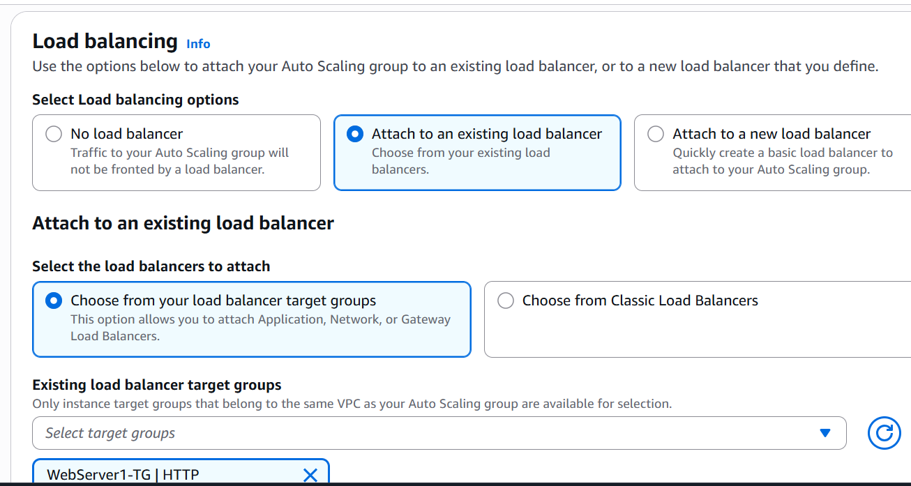
What I did: I selected the option to attach the Auto Scaling group to an existing load balancer/target group.
Explanation: This connects the Auto Scaling instances to the load-balancing setup.

PAGE 37 — AUTO SCALING GROUP
Topic: Health Checks
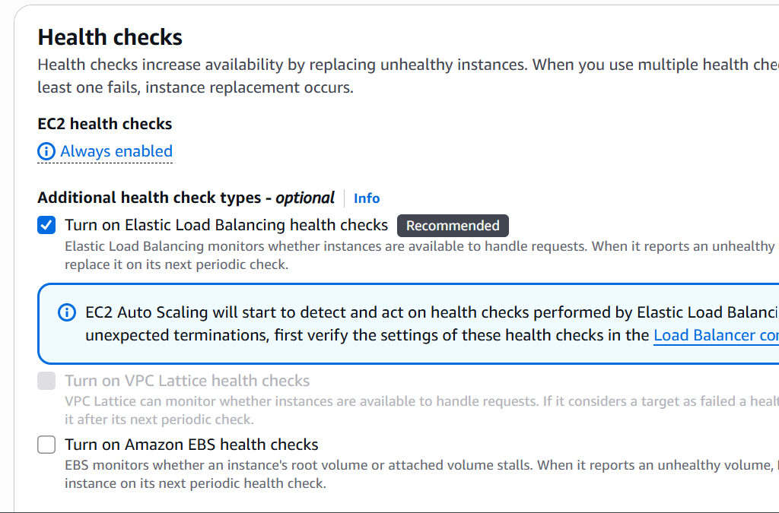
What I did: I reviewed and configured the health-check settings.
Explanation: Health checks allow Auto Scaling to identify unhealthy instances and replace them when needed.

PAGE 38 — AUTO SCALING GROUP
Topic: Health Check Grace Period
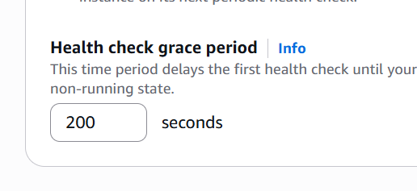
What I did: I set the health-check grace period to 200 seconds.
Explanation: This gives a newly launched instance time to initialize before health checks can cause replacement.

PAGE 39 — AUTO SCALING GROUP
Topic: Next

What I did: I clicked Next to continue.
Explanation: The wizard proceeds to the group-size configuration.

PAGE 40 — AUTO SCALING GROUP
Topic: Group Size
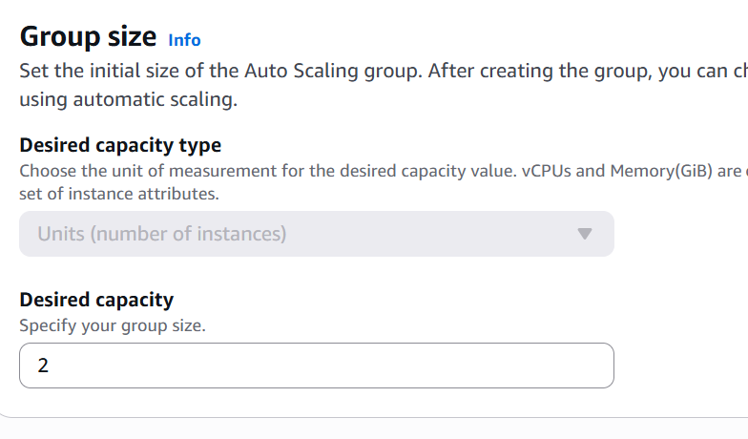
What I did: I configured the desired capacity for the Auto Scaling group.
Explanation: The desired capacity defines how many instances the group should maintain.

PAGE 41 — AUTO SCALING GROUP
Topic: Scaling
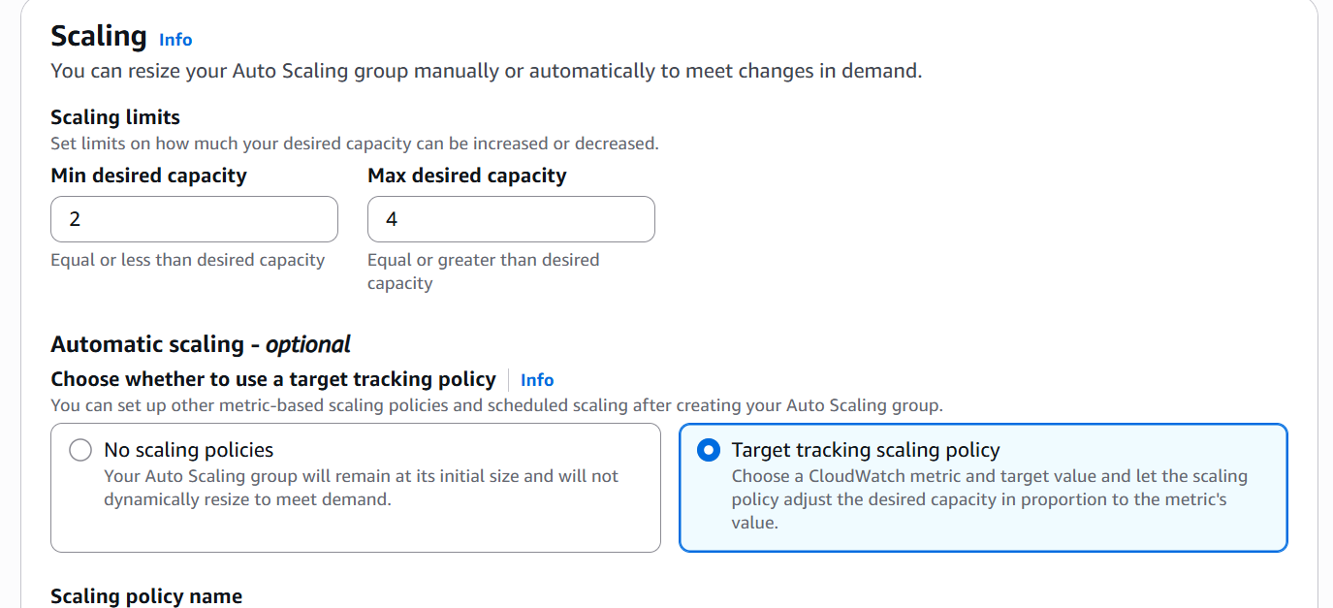
What I did: I configured the scaling settings and automatic scaling option.
Explanation: These settings determine how the Auto Scaling group adjusts capacity when demand changes.

PAGE 42 — AUTO SCALING GROUP
Topic: Scaling Policy
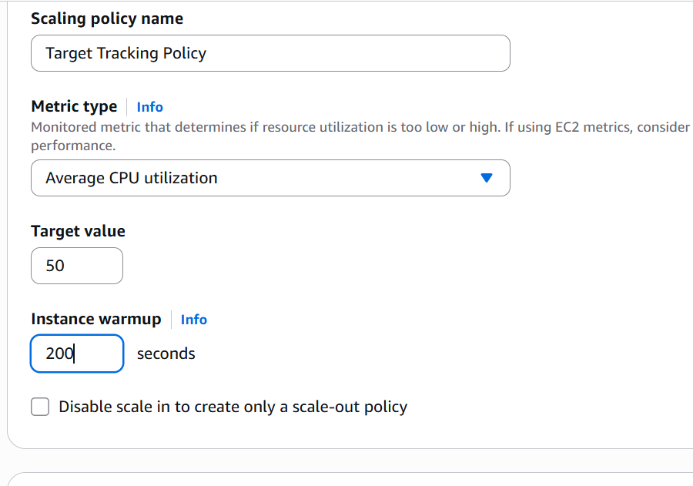
What I did: I configured the target-tracking scaling policy using average CPU utilization.
Explanation: The policy allows the Auto Scaling group to scale according to the selected CPU target.

PAGE 43 — AUTO SCALING GROUP
Topic: Next

What I did: I clicked Next to continue.
Explanation: The wizard proceeds to the final Auto Scaling group creation step.

PAGE 44 — AUTO SCALING GROUP
Topic: Create Auto Scaling Group
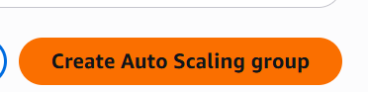
What I did: I selected Create Auto Scaling group.
Explanation: The Auto Scaling group is created using the configured launch template, networking, load balancing, health checks, and scaling settings.

PAGE 45 — AUTO SCALING GROUP
Topic: EC2 Instances
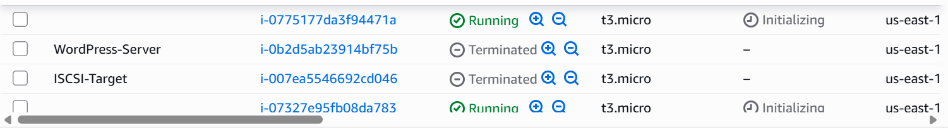
What I did: I reviewed the EC2 instances after creating the Auto Scaling group.
Explanation: The instances list shows the EC2 resources launched by the Auto Scaling configuration.

PAGE 46 — AUTO SCALING GROUP
Topic: Load Balancers

What I did: I reviewed the load balancer after configuration.
Explanation: The load balancer is available to receive and distribute application traffic.

PAGE 47 — AUTO SCALING GROUP
Topic: Application Test
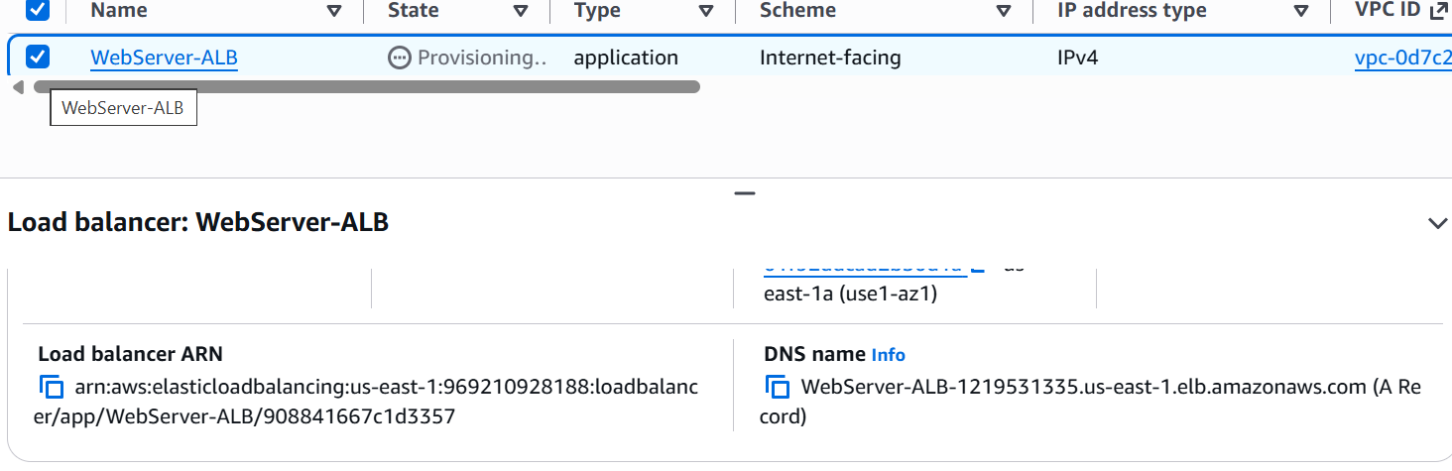
What I did: I opened the application endpoint to test the deployed service.
Explanation: The browser response confirms that the application is reachable through the load-balancing setup.

PAGE 48 — AUTO SCALING GROUP
Topic: Load Balancer Verification
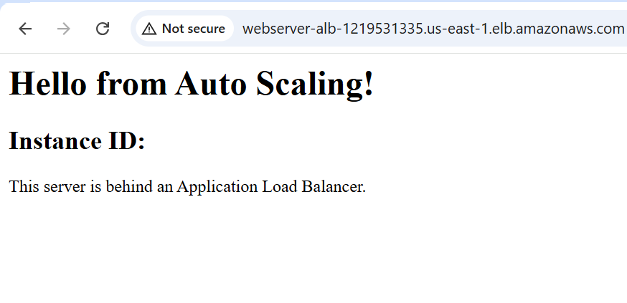
What I did: I reviewed the load balancer and its associated configuration.
Explanation: This final check verifies the load-balancing resources created for the Auto Scaling setup.

PAGE 49 — AUTO SCALING GROUP
Topic: Application Test Result
What I did: I reviewed the application response after accessing the endpoint.
Explanation: The response confirms that the deployed application is responding successfully.

PAGE 50 — AUTO SCALING GROUP
Topic: Final Verification
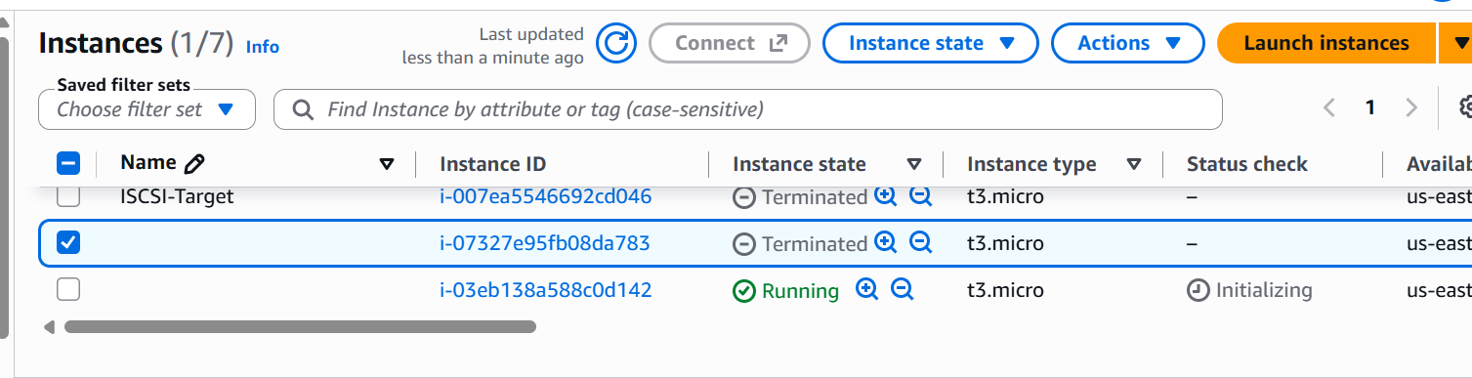
What I did: I reviewed the final AWS resources and their status.
Explanation: This final page verifies the load-balancer and Auto Scaling resources after the configuration.

